Predictive models in the Telecommunications sample

The following models form the basis of the predictive models in the Telecommunications sample:

**Churn model**

Customers likely to churn from the current list of active customers can be predicted.

**Customer Satisfaction model**

Customer satisfaction is determined by the net promoter score.

**Association model**

Customers can be profiled and assigned to segments.

**Response propensity model**

You can determine the correct channel to reach the customer, and the probability that the customer will respond.

* [**Predicting churn**](https://www.ibm.com/support/knowledgecenter/SSCJHT_1.0.0/com.ibm.swg.ba.cognos.pci_oth.1.0.0.doc/c_pci_churn.html?view=kc)

Churn is the measurement of subscribers who ended their contract or services. The objective of the Churn Prediction model in the Telecommunication sample is to predict the customers likely to churn from the current list of active customers.

* [**Customer satisfaction**](https://www.ibm.com/support/knowledgecenter/SSCJHT_1.0.0/com.ibm.swg.ba.cognos.pci_oth.1.0.0.doc/c_pci_cust_sat.html?view=kc)

Customer satisfaction in the Telecommunications sample is determined by the Net Promoter Score (NPS).

* [**Assigning offers**](https://www.ibm.com/support/knowledgecenter/SSCJHT_1.0.0/com.ibm.swg.ba.cognos.pci_oth.1.0.0.doc/c_pci_association_model.html?view=kc)

An Association model is used to assign the right offer to a customer. It uses the customer's segment (for example, Platinum) and predicted net promoter score group (for example, Promoter) to determine an offer (for example Phone Plan).

* [**Targeting offers to customers with the response propensity model**](https://www.ibm.com/support/knowledgecenter/SSCJHT_1.0.0/com.ibm.swg.ba.cognos.pci_oth.1.0.0.doc/c_pci_response_propensity.html?view=kc)

It is important to target offers to the correct customers, through the correct channel.

* [**Telecommunications models in Analytical Decision Management**](https://www.ibm.com/support/knowledgecenter/SSCJHT_1.0.0/com.ibm.swg.ba.cognos.pci_oth.1.0.0.doc/c_pci_telco_adm.html?view=kc)

In IBM® Analytical Decision Management, you can combine predictive models with rules to allocate offers in accordance with business goals. You do this by combining selection and allocation rules that are based on the output from predictive models.

# Predicting churn

Churn is the measurement of subscribers who ended their contract or services. The objective of the Churn Prediction model in the Telecommunication sample is to predict the customers likely to churn from the current list of active customers.

The inputs for the example Churn Prediction model are complaint history, number of months since the customer upgraded the plan, sentiment score, customer demographic history, and estimated income. The example stream for predicting churn is named Churn Prediction.str.

*Figure 1. A model that computes churn scores for customers*

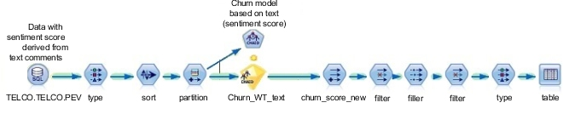

Data preparation for churn prediction starts with aggregating all available information about the customer. The data that is obtained for predicting the churn is classified in the following categories:

* Transaction and billing data, such as the kind of services subscribed, and average monthly bills.
* Demographic data, such as gender, education, and marital status.
* Behavior data, such as complaints data and price plan migration data.
* Usage data, such as the number of calls and the number of text messages sent.

Data is filtered for modeling in two stages:

1. Data not relevant to some customers.
2. Variables that do not have adequate predictive significance.

A CHAID algorithm is used to predict churn. A CHAID algorithm generates decision trees. A decision tree model is selected over logistic regression because the rules that come out of the decision tree help to understand the root cause of churn better.

The sentiment score is derived from the customer comments text and is an important predictor of churn. Sentiment score considers both the current sentiment score and historical sentiment score.

Other important predictors that are identified during the data understanding and modeling phase are estimated income, number of open complaints, number of closed complaints, time since the last plan upgrade, and the education level of the customer.

Along with the probability of churn occurring, the propensity to churn is calculated by the model. The propensity to churn is widely used in the IBM® Analytical Decision Management application. The rule explanation and rule description nodes map the rule identifier number that is generated by the model to the explanation of the rule in English.

# Customer satisfaction

Customer satisfaction in the Telecommunications sample is determined by the Net Promoter Score (NPS).

The Net Promoter Score is based on the perspective that every company's customers can be divided into three categories:

* Promoters are loyal enthusiasts who keep buying from a company and urge their friends to do the same.
* Passives are satisfied but unenthusiastic customers who can be easily wooed by the competition.
* Detractors are unhappy customers who are trapped in a bad relationship with the company.

The Net Promoter Score is obtained by asking a set of customers a single question: "How likely is it that you would recommend our company to a friend or colleague?" Customers are asked to answer on a 0 - 10 rating scale. Based on the score that they provide, they are categorized as Promoter (if the score is 9 or 10), Passive (if the score is 7 or 8), or Detractor (if the score is 6 or less).

The objective of the Net Promoter Score model is to identify the distinguishing characteristics of the customers who fall into the three categories. The net promoter score model is then used to predict which category a customer would fall into, without asking the question "How likely is it that you would recommend our company to a friend or colleague?" This model helps to dynamically track the change in the Net Promoter Score of a customer.

The example stream for identifying the Net Promoter Score is named Satisfaction.str.

*Figure 1. Stream for identifying customer satisfaction*

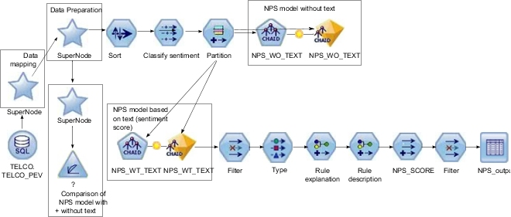

Historical data comes from a sample of customers who answered the question. Customers for whom there is no score are considered to be operational data, whose satisfaction group needs to be predicted for the first time.

The Customer Satisfaction model can be used to predict scores for customers who do not have a net promoter score.

The sentiment score, along with the number of open complaints, employment status, and estimated income, are identified to be the key variables that affect the prediction of satisfaction group. The sentiment score is focused on capturing the negative sentiments across various attributes, such as network and service. A sentiment score of zero means that the customer has not expressed any negative sentiment. A sentiment score of two means that the customer has expressed negative sentiment in two predefined categories. Six categories were defined, and so the maximum sentiment score is 6.

The sentiment score that is used in the example database is an average value of the most recent sentiment score calculated and the previous sentiment score of the same customer. Where a customer expressed negative sentiment on a single category, and then expressed multiple positive comments, the sentiment score would be mildly negative, although close to zero. For the purposes of satisfaction modeling, to avoid categorizing the customer as mildly negative, sentiment scores less than 0.6 are rounded to zero.

# Assigning offers

An Association model is used to assign the right offer to a customer. It uses the customer's segment (for example, Platinum) and predicted net promoter score group (for example, Promoter) to determine an offer (for example Phone Plan).

Segmentation is the process of profiling customers into groups with similar demand characteristics. The example stream for profiling customers is named AssociationModel.str.

The following shows an example association model.

*Figure 1. Association model for the Telecommunications case study*

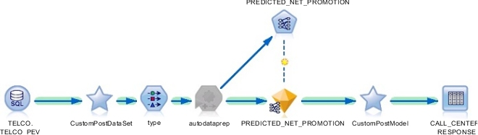

# Targeting offers to customers with the response propensity model

It is important to target offers to the correct customers, through the correct channel.

The Response Propensity model determines the correct channel to reach the customer and determines the probability that the customer will respond.

The example stream for determining response propensity is named ResponsePropensity.str.

*Figure 1. Response propensity model*

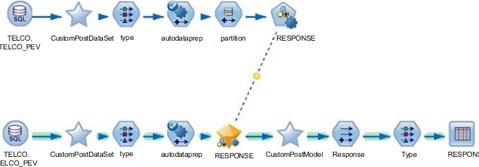

You can use the results of this model to target customers who are likely to respond because they are above a certain threshold or ignore customers who are likely to result in a minimum profit.

The input for the model is customer demographic information, billing history, customer lifetime value, churn score, net promoter score, and tenure.

The customer’s previous offer response data can be used as the input for the current model.

The historical data on which interaction points the customer has responded to an offer is taken and the model is trained based on that data.

# Telecommunications models in Analytical Decision Management

In IBM® Analytical Decision Management, you can combine predictive models with rules to allocate offers in accordance with business goals. You do this by combining selection and allocation rules that are based on the output from predictive models.

There are two main steps:

* Define and allocate offers to determine which offers a customer is eligible for.
* Prioritize offers to determine which offers a customer receives.